Collections in Java

The **Collection in Java** is a framework that provides an architecture to store and manipulate the group of objects.

All the operations that you perform on a data such as searching, sorting, insertion, manipulation, deletion, etc. can be achieved by Java Collections.

Java Collection means a single unit of objects. Java Collection framework provides many interfaces (Set, List, Queue, Deque, etc.) and classes (ArrayList, Vector, LinkedList, PriorityQueue, HashSet, LinkedHashSet, TreeSet, etc.).

What is Collection in java

A Collection represents a single unit of objects, i.e., a group.

What is a framework in Java

* It provides readymade architecture.
* It represents a set of classes and interface.
* It is optional.

What is Collection framework

The Collection framework represents a unified architecture for storing and manipulating a group of objects. It has:

1. Interfaces and its implementations, i.e., classes
2. Algorithm

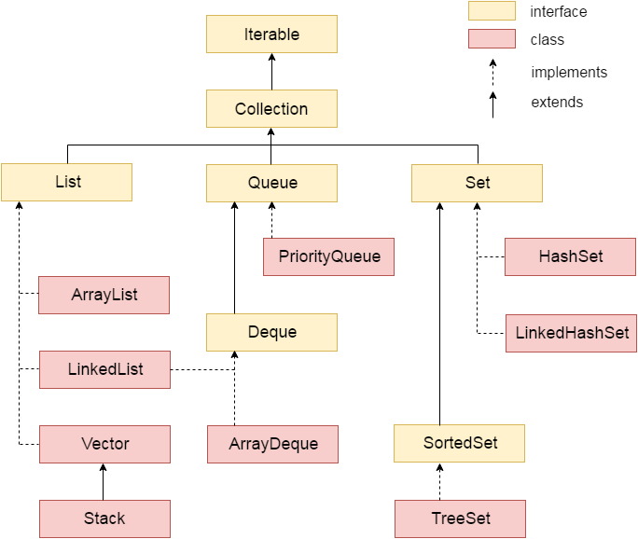

**List vs Queue vs** **Set :-**

A *list* is an ordered list of objects, where the same object may well appear more than once. For example: [1, 7, 1, 3, 1, 1, 1, 5]. It makes sense to talk about the "third element" in a list. You can add an element anywhere in the list, change an element anywhere in the list, or remove an element from any position in the list.

A *queue* is also ordered, but you'll only ever touch elements at one end. All elements get inserted at the "end" and removed from the "beginning" (or head) of the queue. You can find out how many elements are in the queue, but you can't find out what, say, the "third" element is. You'll see it when you get there.

A *set* is not ordered and cannot contain duplicates. Any given object either is or isn't in the set. {7, 5, 3, 1} is the exact same set as {1, 7, 1, 3, 1, 1, 1, 5}. You again can't ask for the "third" element or even the "first" element, since they are not in any particular order. You can add or remove elements, and you can find out if a certain element exists (e.g., "is 7 in this set?")

### Methods of Collection interface

There are many methods declared in the Collection interface. They are as follows:

1 public boolean add(Object element) 🡪is used to insert an element in this collection.

2 public boolean addAll(Collection c) 🡪is used to insert the specified collection elements in the invoking collection.

3 public boolean remove(Object element) 🡪is used to delete an element from this collection.

4 public boolean removeAll(Collection c) 🡪is used to delete all the elements of specified collection from the invoking collection.

5 public boolean retainAll(Collection c) 🡪is used to delete all the elements of invoking collection except the specified collection.

6 public int size() 🡪 return the total number of elements in the collection.

7 public void clear()🡪removes the total no. of elements from the collection.

8 public boolean contains(Object element) 🡪is used to search an element.

9 public boolean containsAll(Collection c) 🡪is used to search the specified collection in this collection.

10 public Iterator iterator()🡪 returns an iterator.

11 public Object[] toArray() 🡪converts collection into array.

12 public boolean isEmpty() 🡪checks if collection is empty.

13 public boolean equals(Object element) 🡪 matches two collections.

14 public int hashCode() 🡪returns the hash code number of the collection.